**Your presentation title**

Firstname Lastname1 and Givenname Familyname1,2

# 1 Department of something, University of somewhere.

2 *APEF Research Institute.*

Write your abstract here. The length should not exceed one page. Generate a PDF file with a name including your name, such as einstein.pdf , then email it to [submit@apef2018.org.](mailto:submit@apef2018.org)

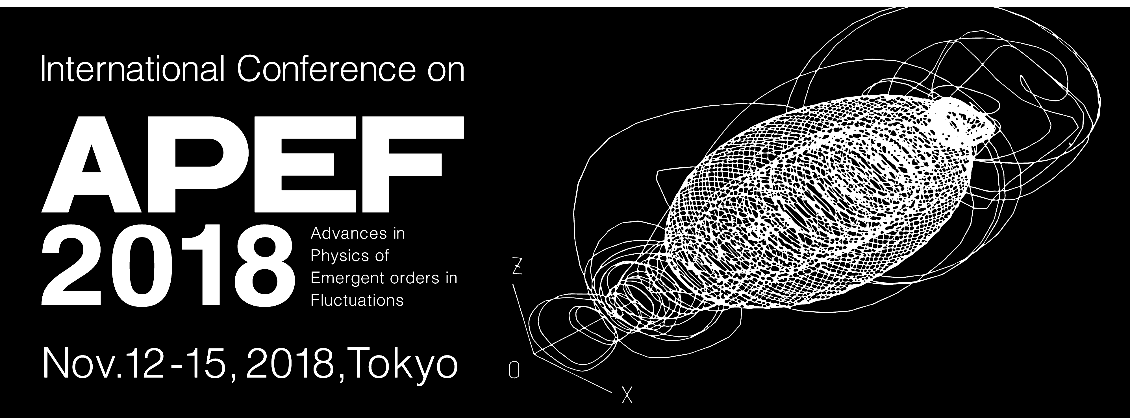

Figure 1: Figure caption.

**References**

[1] M. Kardar, G. Parisi, and Y.-C. Zhang, Phys. Rev. Lett. **56**, 889 (1986).